## Здесь уже используется новая нумерация моделей

## Associations among morphotypes and species-specific genotypes around Kola Peninsular

Table ++. Parameters of regression models fitted

|  |  |  |  |  |
| --- | --- | --- | --- | --- |
| Terms | Estimate | SE | z-statistic | p-value |
| **Model 1** | = 0.38 |  |  |  |
| (Intercept) | -2.7 | 0.15 | -18.23 | < 0.001 |
| Ptros | 4.7 | 0.28 | 16.58 | < 0.001 |
| Subset(BL) | 0.2 | 0.26 | 0.62 | 0.537 |
| Subset(BH) | 2.2 | 0.19 | 11.30 | < 0.001 |
| Ptros:Subset(BL) | -0.5 | 0.45 | -1.03 | 0.302 |
| Ptros:Subset(BH) | -1.4 | 0.43 | -3.38 | 0.001 |
| **Model 2** | = 0.57 | = 0.64 |  |  |
| (Intercept) | -4.2 | 0.38 | -10.89 | < 0.001 |
| Ptros | 4.7 | 0.82 | 5.80 | < 0.001 |
| Subset(BL) | 0.3 | 0.75 | 0.40 | 0.688 |
| Subset(BH) | 3.5 | 0.57 | 6.18 | < 0.001 |
| Species(*M.trossulus*) | 4.2 | 0.45 | 9.34 | < 0.001 |
| Ptros:Subset(BL) | -1.9 | 1.51 | -1.24 | 0.214 |
| Ptros:Subset(BH) | -1.8 | 1.29 | -1.36 | 0.174 |
| Ptros:Species(*M.trossulus*) | -2.5 | 0.83 | -3.02 | 0.003 |
| Subset(BL):Species(*M.trossulus*) | -0.5 | 0.77 | -0.61 | 0.54 |
| Subset(BH):Species(*M.trossulus*) | -3 | 0.62 | -4.87 | < 0.001 |
| Ptros:Subset(BL):Species(*M.trossulus*) | 2.2 | 1.46 | 1.52 | 0.129 |
| Ptros:Subset(BH):Species(*M.trossulus*) | 2.5 | 1.25 | 1.96 | 0.05 |
| sd_(Intercept).pop | 0.8 |  |  |  |
| **Model 3** | = 0.17 |  |  |  |
| (Intercept) | 2.6 | 0.16 | 16.58 | < 0.001 |
| Ptros | -1.9 | 0.28 | -6.82 | < 0.001 |
| Subset(BL) | -0.4 | 0.28 | -1.53 | 0.127 |
| Subset(BH) | -2.4 | 0.2 | -12.29 | < 0.001 |
| Ptros:Subset(BL) | 1.1 | 0.47 | 2.26 | 0.024 |
| Ptros:Subset(BH) | 2.6 | 0.39 | 6.66 | < 0.001 |
| **Model 4** | = 0.4 | = 0.42 |  |  |
| (Intercept) | 3.8 | 0.28 | 13.99 | < 0.001 |
| Morph(T) | -3.8 | 0.41 | -9.12 | < 0.001 |
| Ptros | -5.2 | 0.55 | -9.57 | < 0.001 |
| Subset(BL) | -0.4 | 0.47 | -0.88 | 0.377 |
| Subset(BH) | -0.6 | 0.47 | -1.21 | 0.226 |
| Morph(T):Ptros | 8.1 | 0.78 | 10.40 | < 0.001 |
| Morph(T):Subset(BL) | 0.8 | 0.73 | 1.09 | 0.276 |
| Morph(T):Subset(BH) | -1.6 | 0.58 | -2.71 | 0.007 |
| Ptros:Subset(BL) | 0.8 | 0.9 | 0.91 | 0.361 |
| Ptros:Subset(BH) | 0.4 | 1.02 | 0.36 | 0.72 |
| Morph(T):Ptros:Subset(BL) | -0.3 | 1.37 | -0.21 | 0.83 |
| Morph(T):Ptros:Subset(BH) | 1.4 | 1.2 | 1.16 | 0.244 |
| sd_(Intercept).pop | 0.3 |  |  |  |
| **Model 5** | = 0.42 |  |  |  |
| (Intercept) | -2.5 | 0.14 | -17.97 | < 0.001 |
| PT | 5.3 | 0.32 | 16.73 | < 0.001 |
| Subset(BL) | 0.3 | 0.25 | 1.12 | 0.264 |
| Subset(BH) | -1.3 | 0.33 | -4.06 | < 0.001 |
| PT:Subset(BL) | 0.3 | 0.58 | 0.54 | 0.588 |
| PT:Subset(BH) | -0.3 | 0.53 | -0.54 | 0.591 |
| **Model 6** | = 0.5 | = 0.51 |  |  |
| (Intercept) | 3.7 | 0.21 | 17.23 | < 0.001 |
| Morph(T) | -3.5 | 0.33 | -10.50 | < 0.001 |
| Ptros | -4.9 | 0.41 | -12.00 | < 0.001 |
| Subset(BH) | -0.4 | 0.43 | -1.00 | 0.318 |
| SubsetGOM | 1 | 0.58 | 1.78 | 0.074 |
| SubsetBALT | -0.9 | 0.41 | -2.28 | 0.023 |
| SubsetNORW | -0.6 | 0.61 | -1.00 | 0.315 |
| Morph(T):Ptros | 8.1 | 0.63 | 12.90 | < 0.001 |
| Morph(T):Subset(BH) | -1.8 | 0.53 | -3.43 | 0.001 |
| Morph(T):SubsetGOM | -1.8 | 0.84 | -2.18 | 0.029 |
| Morph(T):SubsetBALT | 0.4 | 1.54 | 0.23 | 0.82 |
| Morph(T):SubsetNORW | -1.1 | 1.17 | -0.95 | 0.343 |
| Ptros:Subset(BH) | 0.1 | 0.93 | 0.09 | 0.928 |
| Ptros:SubsetGOM | -3.2 | 1.08 | -2.92 | 0.003 |
| Ptros:SubsetBALT | -0.5 | 0.72 | -0.72 | 0.47 |
| Ptros:SubsetNORW | 0 | 0.95 | -0.05 | 0.959 |
| Morph(T):Ptros:Subset(BH) | 1.4 | 1.1 | 1.27 | 0.204 |
| Morph(T):Ptros:SubsetGOM | 4.8 | 1.88 | 2.57 | 0.01 |
| Morph(T):Ptros:SubsetBALT | 1.2 | 2.2 | 0.55 | 0.579 |
| Morph(T):Ptros:SubsetNORW | 3.6 | 1.94 | 1.86 | 0.063 |
| sd_(Intercept).pop | 0.3 |  |  |  |
| **Model 7** | = 0.42 |  |  |  |
| (Intercept) | -2.4 | 0.11 | -21.34 | < 0.001 |
| PT | 5.4 | 0.26 | 20.74 | < 0.001 |
| Subset(BH) | -1.5 | 0.32 | -4.55 | < 0.001 |
| SubsetGOM | 0.1 | 0.22 | 0.69 | 0.492 |
| SubsetBALT | 1.8 | 0.16 | 11.01 | < 0.001 |
| SubsetNORW | 1.9 | 0.22 | 8.91 | < 0.001 |
| PT:Subset(BH) | -0.4 | 0.5 | -0.87 | 0.386 |
| PT:SubsetGOM | 0.8 | 0.74 | 1.04 | 0.299 |
| PT:SubsetBALT | 6.1 | 1.22 | 5.05 | < 0.001 |
| PT:SubsetNORW | -1.8 | 0.62 | -2.81 | 0.005 |
| **Model 8** | = 0.57 | = 0.66 |  |  |
| (Intercept) | -4.2 | 0.36 | -11.64 | < 0.001 |
| Ptros | 4.2 | 0.74 | 5.70 | < 0.001 |
| Subset(BH) | 3.6 | 0.62 | 5.77 | < 0.001 |
| SubsetGOM | 0.4 | 0.63 | 0.55 | 0.579 |
| SubsetBALT | -2.8 | 1.7 | -1.63 | 0.102 |
| SubsetNORW | 1.3 | 1.05 | 1.27 | 0.205 |
| Species(*M.trossulus*) | 4.1 | 0.37 | 11.04 | < 0.001 |
| Ptros:Subset(BH) | -1.1 | 1.37 | -0.82 | 0.414 |
| Ptros:SubsetGOM | -1.7 | 1.76 | -0.98 | 0.326 |
| Ptros:SubsetBALT | 1.3 | 2.56 | 0.51 | 0.612 |
| Ptros:SubsetNORW | -5.7 | 2.04 | -2.79 | 0.005 |
| Ptros:Species(*M.trossulus*) | -1.7 | 0.68 | -2.45 | 0.014 |
| Subset(BH):Species(*M.trossulus*) | -2.9 | 0.57 | -5.16 | < 0.001 |
| SubsetGOM:Species(*M.trossulus*) | 0.5 | 0.98 | 0.52 | 0.605 |
| SubsetBALT:Species(*M.trossulus*) | -1.4 | 1.64 | -0.85 | 0.397 |
| SubsetNORW:Species(*M.trossulus*) | -2.3 | 1.28 | -1.82 | 0.069 |
| Ptros:Subset(BH):Species(*M.trossulus*) | 1.6 | 1.17 | 1.41 | 0.159 |
| Ptros:SubsetGOM:Species(*M.trossulus*) | -2.1 | 2.02 | -1.04 | 0.296 |
| Ptros:SubsetBALT:Species(*M.trossulus*) | -0.4 | 2.41 | -0.17 | 0.863 |
| Ptros:SubsetNORW:Species(*M.trossulus*) | 3.5 | 2.03 | 1.73 | 0.083 |
| sd_(Intercept).pop | 0.9 |  |  |  |

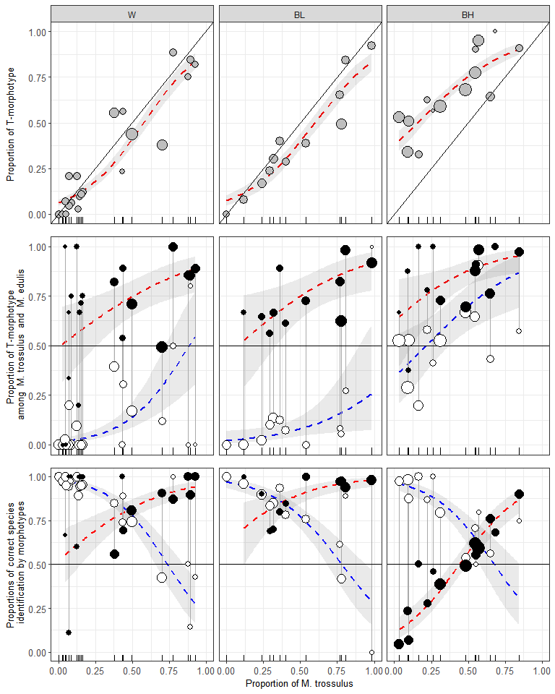

Figure ++. Variation of PT, P(T|tros), P(E|edu), P(tros|T), P(edu|E) as functions of Ptros in the White Sea (WS), brackish Barents Sea (BL) and saline Barents Sea (BH). Points - empirical estimates, size is proportional to sample sizes. Lines – regression model predictions, grey filling – 95% confidence intervals of regressions. (A) Proportions of T-morphotypes (PT) (Model 1). (B). Proportions of T-morphotypes among M. trossulus (filled points) and M. edulis (empty points) (Model 2). (C) Frequencies of M. trossulus among T-morphotypes (filled points) and of M. edulis among E-morphotypes (Model 4). Vertical lines on B and C connect subsamples of *M. trossulus* and *M. edulis* from the same samples.

Для параноиков. Таблицы с оценкой статистической значимости связи вероятности встретить Т-морфотип с размером

**Для M.trossulus**

|  |  |  |  |  |  |  |
| --- | --- | --- | --- | --- | --- | --- |
| pop | term | estimate | std.error | statistic | p.value | p_adj |
| abram | size | -0.1108248 | 8.944830e-02 | -1.2389827 | 0.2154 | 1.0000 |
| banka | size | 0.0228602 | 8.021860e-02 | 0.2849741 | 0.7757 | 1.0000 |
| belok | size | 0.0181256 | 4.231480e-02 | 0.4283507 | 0.6684 | 1.0000 |
| belok2 | size | -0.0442341 | 2.742920e-02 | -1.6126654 | 0.1068 | 1.0000 |
| Berg_new | size | -0.1097372 | 5.619000e-02 | -1.9529682 | 0.0508 | 1.0000 |
| Bergen_MV | size | -0.1008587 | 2.056170e-02 | -4.9051675 | 0.0000 | 0.0000 |
| Bergen04 | size | -0.0317087 | 1.865130e-01 | -0.1700077 | 0.8650 | 1.0000 |
| berzakol | size | 0.4532150 | 7.388397e-01 | 0.6134145 | 0.5396 | 1.0000 |
| bukhtovka | size | 0.4250105 | 3.242314e-01 | 1.3108246 | 0.1899 | 1.0000 |
| CBCP | size | 0.0000000 | 9.681266e+03 | 0.0000000 | 1.0000 | 1.0000 |
| CBE | size | 0.0928196 | 6.994610e-02 | 1.3270169 | 0.1845 | 1.0000 |
| CBSC | size | 0.0000000 | 1.028704e+04 | 0.0000000 | 1.0000 | 1.0000 |
| CBSL | size | 0.1843246 | 1.162855e-01 | 1.5851044 | 0.1129 | 1.0000 |
| chupa | size | 0.0388994 | 3.553700e-02 | 1.0946194 | 0.2737 | 1.0000 |
| dz_banka | size | -0.0542257 | 1.170614e-01 | -0.4632244 | 0.6432 | 1.0000 |
| dz_lit | size | -6.0847916 | 1.397308e+04 | -0.0004355 | 0.9997 | 1.0000 |
| Esp_MV | size | -0.3247392 | 9.102498e-01 | -0.3567583 | 0.7213 | 1.0000 |
| Esp04 | size | 0.0000000 | 8.584261e+03 | 0.0000000 | 1.0000 | 1.0000 |
| fr | size | -0.2108958 | 1.094794e-01 | -1.9263522 | 0.0541 | 1.0000 |
| ivan_buy | size | 0.0000001 | 5.707044e+03 | 0.0000000 | 1.0000 | 1.0000 |
| ivan_us | size | 0.0000000 | 5.113939e+03 | 0.0000000 | 1.0000 | 1.0000 |
| ivan2 | size | 0.3252129 | 7.520373e-01 | 0.4324425 | 0.6654 | 1.0000 |
| ivan3 | size | -0.0117252 | 3.013270e-02 | -0.3891189 | 0.6972 | 1.0000 |
| kanal | size | 0.0234291 | 5.116700e-02 | 0.4578946 | 0.6470 | 1.0000 |
| kast05 | size | 0.0000000 | 1.431588e+04 | 0.0000000 | 1.0000 | 1.0000 |
| kast87 | size | -0.1083427 | 1.216691e-01 | -0.8904703 | 0.3732 | 1.0000 |
| kovda | size | 0.4828767 | 4.098653e-01 | 1.1781353 | 0.2387 | 1.0000 |
| kuvsh | size | -0.0228386 | 1.002985e-01 | -0.2277059 | 0.8199 | 1.0000 |
| LE | size | 0.0000000 | 1.334664e+04 | 0.0000000 | 1.0000 | 1.0000 |
| Limh08 | size | -0.0444674 | 8.325400e-02 | -0.5341168 | 0.5933 | 1.0000 |
| Limh88 | size | 0.0985738 | 1.257655e-01 | 0.7837910 | 0.4332 | 1.0000 |
| luv_korg | size | -3.0885802 | 6.245287e+03 | -0.0004945 | 0.9996 | 1.0000 |
| luv_mat | size | 0.0000000 | 8.033788e+03 | 0.0000000 | 1.0000 | 1.0000 |
| MDRE | size | 0.0000000 | 1.170354e+04 | 0.0000000 | 1.0000 | 1.0000 |
| MDRW | size | 0.1805985 | 1.986924e-01 | 0.9089352 | 0.3634 | 1.0000 |
| mi | size | 0.0337182 | 2.652330e-02 | 1.2712640 | 0.2036 | 1.0000 |
| niva_sl | size | 33.3162751 | 1.573704e+04 | 0.0021171 | 0.9983 | 1.0000 |
| nm_last | size | -0.1699536 | 1.100788e-01 | -1.5439272 | 0.1226 | 1.0000 |
| oenij | size | -0.0497075 | 4.413490e-02 | -1.1262646 | 0.2601 | 1.0000 |
| PL | size | 0.0457526 | 1.251185e-01 | 0.3656738 | 0.7146 | 1.0000 |
| porya | size | 0.1093742 | 1.445263e-01 | 0.7567767 | 0.4492 | 1.0000 |
| rya | size | 0.0485582 | 5.827710e-02 | 0.8332296 | 0.4047 | 1.0000 |
| salnij | size | -0.0581087 | 6.505810e-02 | -0.8931819 | 0.3718 | 1.0000 |
| seredina | size | -0.0486490 | 1.029052e-01 | -0.4727556 | 0.6364 | 1.0000 |
| seredina_sub | size | -0.1112264 | 4.070950e-02 | -2.7321961 | 0.0063 | 0.4032 |
| sevsk | size | -0.0415182 | 5.477780e-02 | -0.7579380 | 0.4485 | 1.0000 |
| Solvesborg | size | 0.0500393 | 9.505030e-02 | 0.5264510 | 0.5986 | 1.0000 |
| tu_old | size | 0.0677881 | 8.934310e-02 | 0.7587384 | 0.4480 | 1.0000 |
| umba | size | -0.0521419 | 3.394190e-02 | -1.5362109 | 0.1245 | 1.0000 |
| umba_pikut | size | -0.0681524 | 1.837586e-01 | -0.3708799 | 0.7107 | 1.0000 |
| umba_pil | size | 0.0000000 | 6.935617e+03 | 0.0000000 | 1.0000 | 1.0000 |
| umba_sovhoz | size | -0.2278249 | 2.892604e-01 | -0.7876118 | 0.4309 | 1.0000 |
| ustie | size | -0.0541400 | 6.392150e-02 | -0.8469766 | 0.3970 | 1.0000 |
| ustie_sub | size | -0.0563161 | 2.210170e-02 | -2.5480402 | 0.0108 | 0.6804 |
| Vhg05 | size | -0.2906209 | 2.303068e-01 | -1.2618858 | 0.2070 | 1.0000 |
| Vhg88 | size | 0.0459479 | 4.954360e-02 | 0.9274233 | 0.3537 | 1.0000 |
| vol | size | 0.0244604 | 3.342290e-02 | 0.7318447 | 0.4643 | 1.0000 |
| vor1 | size | -3.8566784 | 7.148998e+03 | -0.0005395 | 0.9996 | 1.0000 |
| vor2 | size | 0.0000000 | 1.677257e+04 | 0.0000000 | 1.0000 | 1.0000 |
| vor5 | size | 0.0000000 | 1.677258e+04 | 0.0000000 | 1.0000 | 1.0000 |
| voronya | size | -20.5066666 | 3.084329e+04 | -0.0006649 | 0.9995 | 1.0000 |
| yarn02 | size | -0.0000001 | 1.504645e+04 | 0.0000000 | 1.0000 | 1.0000 |
| yokanga | size | 0.0500410 | 8.065630e-02 | 0.6204234 | 0.5350 | 1.0000 |
| Ystad05 | size | -0.1691679 | 7.659470e-02 | -2.2086115 | 0.0272 | 1.0000 |
| zmis | size | 0.3348717 | 5.393720e-01 | 0.6208549 | 0.5347 | 1.0000 |

**Для M.edulis**

|  |  |  |  |  |  |  |
| --- | --- | --- | --- | --- | --- | --- |
| pop | term | estimate | std.error | statistic | p.value | p_adj |
| abram | size | 0.0348846 | 9.983410e-02 | 0.3494260 | 0.7268 | 1.0000 |
| banka | size | -0.0841483 | 2.227860e-02 | -3.7770844 | 0.0002 | 0.0144 |
| belok | size | 0.1327493 | 5.183180e-02 | 2.5611567 | 0.0104 | 0.7280 |
| Berg_new | size | 0.0000000 | 1.057923e+04 | 0.0000000 | 1.0000 | 1.0000 |
| Bergen_MV | size | -0.0347578 | 4.661700e-02 | -0.7456029 | 0.4559 | 1.0000 |
| Bergen04 | size | 0.0000000 | 8.725781e+03 | 0.0000000 | 1.0000 | 1.0000 |
| berzakol | size | 0.0000000 | 8.535401e+03 | 0.0000000 | 1.0000 | 1.0000 |
| BI | size | 0.0000000 | 1.476227e+04 | 0.0000000 | 1.0000 | 1.0000 |
| bukhtovka | size | 0.0466742 | 5.382040e-02 | 0.8672213 | 0.3858 | 1.0000 |
| CBCP | size | 0.0000000 | 7.394430e+03 | 0.0000000 | 1.0000 | 1.0000 |
| CBSC | size | 0.4864048 | 4.895929e-01 | 0.9934883 | 0.3205 | 1.0000 |
| CBSL | size | 0.0482970 | 1.757988e-01 | 0.2747290 | 0.7835 | 1.0000 |
| chupa | size | -0.0690996 | 7.600370e-02 | -0.9091603 | 0.3633 | 1.0000 |
| dz_banka | size | -0.0397191 | 2.144620e-02 | -1.8520382 | 0.0640 | 1.0000 |
| dz_lit | size | -0.0134375 | 2.930620e-02 | -0.4585212 | 0.6466 | 1.0000 |
| Esp_MV | size | -0.0035052 | 5.255970e-02 | -0.0666892 | 0.9468 | 1.0000 |
| Esp04 | size | 0.0000000 | 1.272473e+04 | 0.0000000 | 1.0000 | 1.0000 |
| fr | size | -0.1333515 | 7.624670e-02 | -1.7489481 | 0.0803 | 1.0000 |
| ivan_buy | size | 0.0000000 | 4.120860e+03 | 0.0000000 | 1.0000 | 1.0000 |
| ivan_us | size | -0.0789455 | 5.764080e-02 | -1.3696127 | 0.1708 | 1.0000 |
| ivan2 | size | 0.0000000 | 1.079564e+04 | 0.0000000 | 1.0000 | 1.0000 |
| ivan3 | size | -0.0515276 | 1.606121e-01 | -0.3208199 | 0.7483 | 1.0000 |
| JPC | size | 0.0268075 | 2.495171e-01 | 0.1074373 | 0.9144 | 1.0000 |
| kanal | size | 27.3190547 | 2.995682e+04 | 0.0009119 | 0.9993 | 1.0000 |
| kast05 | size | 0.0000000 | 4.801049e+03 | 0.0000000 | 1.0000 | 1.0000 |
| kast87 | size | -0.1805728 | 2.310627e-01 | -0.7814883 | 0.4345 | 1.0000 |
| KIM | size | -0.0018190 | 1.035430e-01 | -0.0175675 | 0.9860 | 1.0000 |
| kovda | size | 0.0000000 | 3.699468e+03 | 0.0000000 | 1.0000 | 1.0000 |
| kuvsh | size | 0.3147051 | 2.370035e-01 | 1.3278499 | 0.1842 | 1.0000 |
| LE | size | 0.0000000 | 7.619990e+03 | 0.0000000 | 1.0000 | 1.0000 |
| Limh08 | size | -0.1322596 | 1.875566e-01 | -0.7051720 | 0.4807 | 1.0000 |
| Limh88 | size | 0.0000000 | 1.153142e+04 | 0.0000000 | 1.0000 | 1.0000 |
| luv_korg | size | 0.0000000 | 1.227471e+04 | 0.0000000 | 1.0000 | 1.0000 |
| luv_mat | size | -0.1043326 | 1.234544e-01 | -0.8451105 | 0.3980 | 1.0000 |
| MDICOA | size | -6.6291247 | 4.693919e+03 | -0.0014123 | 0.9989 | 1.0000 |
| MDRE | size | 0.3647313 | 3.214035e-01 | 1.1348082 | 0.2565 | 1.0000 |
| MDRW | size | -0.0855364 | 1.557831e-01 | -0.5490735 | 0.5830 | 1.0000 |
| mi | size | 0.0379692 | 1.291182e-01 | 0.2940655 | 0.7687 | 1.0000 |
| niva_sl | size | 0.1660846 | 9.957490e-02 | 1.6679361 | 0.0953 | 1.0000 |
| nm | size | 0.0000000 | 7.858943e+03 | 0.0000000 | 1.0000 | 1.0000 |
| nm_last | size | -0.0177127 | 4.662920e-02 | -0.3798640 | 0.7040 | 1.0000 |
| oenij | size | 0.0000000 | 1.161015e+04 | 0.0000000 | 1.0000 | 1.0000 |
| padan | size | 0.0000000 | 6.190601e+03 | 0.0000000 | 1.0000 | 1.0000 |
| PH | size | -0.0513918 | 9.269990e-02 | -0.5543886 | 0.5793 | 1.0000 |
| PL | size | 0.4477981 | 3.135296e-01 | 1.4282483 | 0.1532 | 1.0000 |
| porya | size | 0.0000000 | 3.231783e+03 | 0.0000000 | 1.0000 | 1.0000 |
| rya | size | 0.0628899 | 3.368810e-02 | 1.8668299 | 0.0619 | 1.0000 |
| salnij | size | 0.0000000 | 2.161082e+04 | 0.0000000 | 1.0000 | 1.0000 |
| seredina | size | -0.0526104 | 3.931170e-02 | -1.3382909 | 0.1808 | 1.0000 |
| seredina_sub | size | -0.0705725 | 2.411950e-02 | -2.9259487 | 0.0034 | 0.2414 |
| sevsk | size | 0.0000000 | 9.079304e+03 | 0.0000000 | 1.0000 | 1.0000 |
| tu_old | size | -0.0383189 | 9.161670e-02 | -0.4182527 | 0.6758 | 1.0000 |
| umba | size | -0.1243559 | 7.302580e-02 | -1.7029035 | 0.0886 | 1.0000 |
| umba_06 | size | 0.0000000 | 6.594840e+03 | 0.0000000 | 1.0000 | 1.0000 |
| umba_bridge | size | 0.0000000 | 8.818480e+03 | 0.0000000 | 1.0000 | 1.0000 |
| umba_kamni | size | 0.0000000 | 1.183647e+04 | 0.0000000 | 1.0000 | 1.0000 |
| umba_pikut | size | 0.0000000 | 5.299659e+03 | 0.0000000 | 1.0000 | 1.0000 |
| umba_pil | size | 0.1629761 | 1.999680e-01 | 0.8150110 | 0.4151 | 1.0000 |
| umba_pioner | size | 0.0000000 | 8.159787e+03 | 0.0000000 | 1.0000 | 1.0000 |
| umba_sovhoz | size | 0.0000000 | 6.172554e+03 | 0.0000000 | 1.0000 | 1.0000 |
| ustie | size | -0.0354519 | 4.461180e-02 | -0.7946757 | 0.4268 | 1.0000 |
| ustie_sub | size | -0.1009798 | 2.352760e-02 | -4.2919668 | 0.0000 | 0.0000 |
| VH | size | 0.0000000 | 1.113020e+04 | 0.0000000 | 1.0000 | 1.0000 |
| Vhg05 | size | 0.0000000 | 8.399645e+03 | 0.0000000 | 1.0000 | 1.0000 |
| Vhg88 | size | 0.0849415 | 1.601970e-01 | 0.5302314 | 0.5960 | 1.0000 |
| vol | size | 0.0510169 | 4.593410e-02 | 1.1106540 | 0.2667 | 1.0000 |
| vor1 | size | 0.0179428 | 5.879810e-02 | 0.3051587 | 0.7602 | 1.0000 |
| vor2 | size | 0.0000000 | 9.819141e+03 | 0.0000000 | 1.0000 | 1.0000 |
| vor5 | size | 0.0068308 | 1.325602e-01 | 0.0515297 | 0.9589 | 1.0000 |
| voronya | size | 0.0000000 | 6.170223e+03 | 0.0000000 | 1.0000 | 1.0000 |
| yarn02 | size | -0.0150716 | 1.314686e-01 | -0.1146400 | 0.9087 | 1.0000 |
| yokanga | size | -0.0348270 | 1.553357e-01 | -0.2242048 | 0.8226 | 1.0000 |
| zmis | size | 0.1204233 | 1.517257e-01 | 0.7936907 | 0.4274 | 1.0000 |

## Associations between phenotypic and genotypic structure of populations around Atlantics

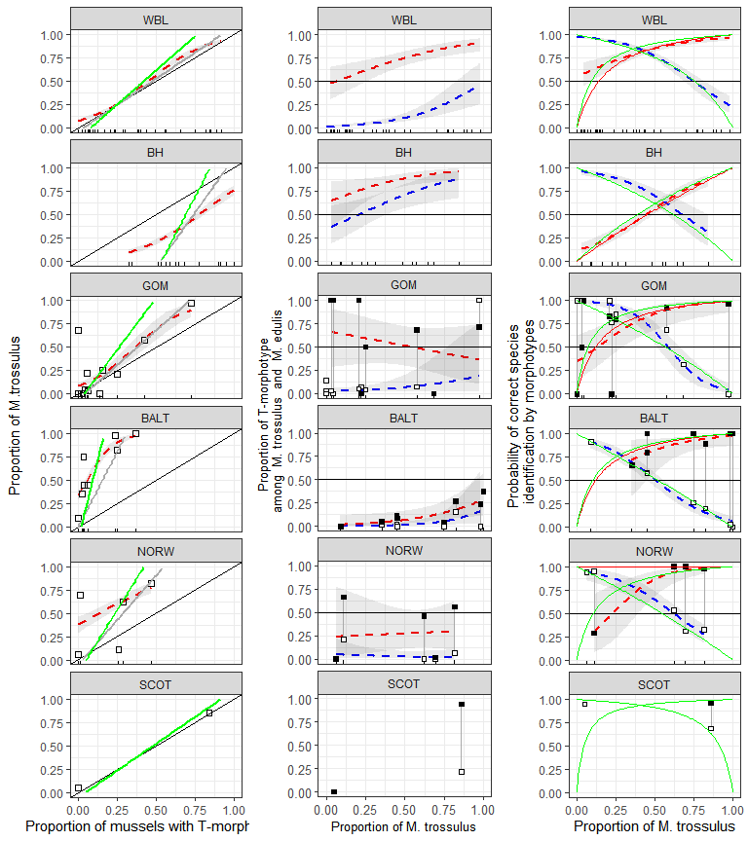

Figure ++. Predictive power of morphotype test in different regions. (A) Dependence of Ptros on proportion of T-morphotype mussels. Dotted line is empirical regression line (Model 7). Solid gray line - prediction accordingly to Eq. 3. Solid black lines represent Y=X dependence. (B) Probability to find a mussel with T-morphotype among M.edulis and M.trossulus. Dotted lines correspond to regression Model 8. Black squares - M.trossulus, white - M.edulis. (C) Probability of correct species identification by morphotype-test. Dotted lines are empirical regression lines (Model 6). Sold red line - prediction by Eq.1, Solid blue line - prediction by Eq.2. Shedded areas around regression lines represent 95% CI. For WBL and BH dots represent testing data sets in all other cases dots represent data used for constructing corresponding regression models.

Table ++. Predicted values of probability of correct species identification by mussel morphotype in mixed populations (Ptros = 0.5) in different geographical regions. Low and upper boundaries of 95% conficencal intervals are given for predicted values.

|  |  |  |  |  |  |  |
| --- | --- | --- | --- | --- | --- | --- |
| Subset | P(edu|E) |  |  | P(tros|T) |  |  |
|  | Predicted | Low | Up | Predicted | Low | Up |
| WBL | 0.77 | 0.73 | 0.81 | 0.85 | 0.82 | 0.89 |
| BH | 0.7 | 0.61 | 0.78 | 0.57 | 0.51 | 0.63 |
| GOM | 0.66 | 0.54 | 0.77 | 0.86 | 0.68 | 0.95 |
| BALT | 0.51 | 0.44 | 0.58 | 0.82 | 0.58 | 0.94 |
| NORW | 0.64 | 0.53 | 0.74 | 0.86 | 0.68 | 0.95 |

Table +. Proportion of mussels correctly identified by morphotype test in different regions

|  |  |  |
| --- | --- | --- |
| Region | E-morphotype as M.edulis | T-morphotype as M.trossulus |
| WBL | 0.74 | 0.72 |
| BH | 0.76 | 0.02 |
| GOM | 0.82 | 0.62 |
| BALT | 0.00 | 0.81 |
| NORW | 0.00 | 0.92 |

## Using the probability theory equation (Eq 1, 2, 3) for express assessments by morphotype test

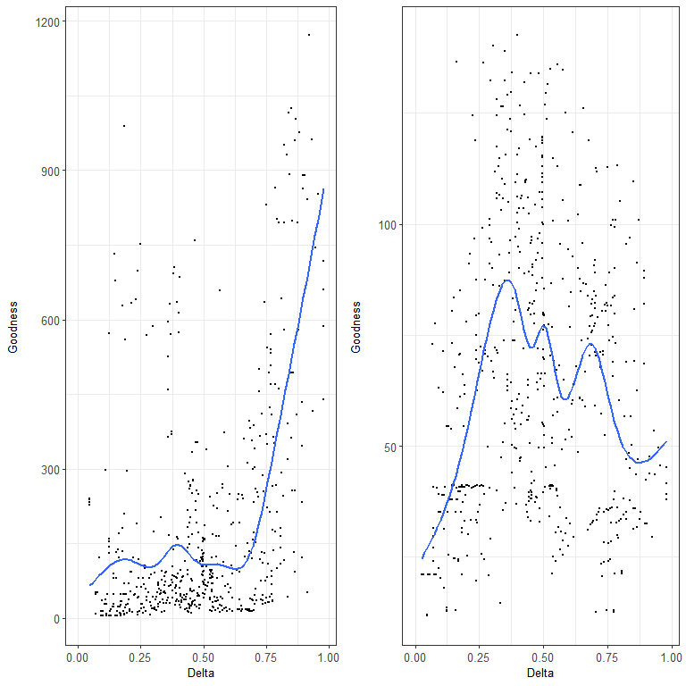

Figure +. Correspondence between regression and theoretical models. Each point corresponds to one of the possible pairs of populations from modelling data set (White Sea joined with low salinity Barens Sea). OX axis represents the differencу in genetic structre for each pair of populations. OY axis represents correspondence between prediction of regression model and theoretical model. Lines represent LOESS-smoother. (A ) Model 7 describing the dependence of proportion of M.trossulus (Ptros) on proportion of T-morphotype (P_T) ; (B) Model 6 describing the dependence of probability of correct species identification on proportion of M.trossulus and morphotype.

## Формулы для моделей

**Модель 7**, описывающия связь между Ptros и PT для всех изученных регионов

Для WBL

Для BH

Для GOM

Для BALT

Для NORW

**Модель 6**, описывающия вероятности правильного определения вида по морфотипу с Ptros для всех изученных регионов

**For WBL Set**

E-morphotype

T-morphotype

**For BH Set**

E-morphotype

T-morphotype

**For GOM Set**

E-morphotype

T-morphotype

**For BALT Set**

E-morphotype

T-morphotype

**For NORW Set**

E-morphotype

T-morphotype